
wDatabase Management I (420-J10-HR)

Happy Valley Kennels Project

Assignment 3 - Physical Data Model and Database Schema (Group assignment – HVK teams)
Date assigned: Friday October 10
Date due: Friday, October 17 at 23h50
Initial workplan due Friday October 10
You will be given time during one lab period, on Friday October 11th, to work on this assignment. You must organize other time to work with your team to complete the assignment.
Progress submission will be required at the end of the lab block used for the assignment. It must contain the corrected Assignment 2 content as well as any other progress on Assignment 3 content.
Learning Objectives
After completing this assignment, the student will be able to:
- choose appropriate datatypes, lengths, valid values, and defaults for attributes;
- decide on referential integrity constraints for relationships;
- specify datatypes, lengths, valid values and defaults for attributes
- convert a logical data model to an implementation model (i.e. create a real database from the model)
- create tables, primary keys, and foreign keys
- populate your database with provided data

Each team has a predefined DB (all empty, no tables) setup for them on our DB server. It’s J10_HVK_Txx where xx is your team number. i.e. Team 5 will use J10_HVK_T05.
The goal for this assignment is to transition from the A02 logical model to the physical database on the DB server.
Once the DB is created, you will populate it and prove that it is a working DB.
As you go through getting the DB to work, track your items/changes in the ChangeLog provided.
Review this Assignment completely before starting. Put together a plan that you will review with the professor before the end of the Friday Oct 10 lab session. It must show a list of tasks, an estimate of hours and who is assigned to the task (just like A01). Update this plan when you submit your assignment to reflect what actually happened.
References
1. Look up available data types available before assigning data types to your attributes. See here
2. See sample SQL scripts for creating and configuring DBs. I’ve provided one in the Resources folder for this course. You can also look at it via SSMS (it’s the J10_DB1 database).
3. Make sure that your ERDPlus Relational schema model is good, because it’s not easy to go back and forth between the Logical model and the Physical model. For the most part, consider it a one way trip. Make sure that all tables have PKs. Our naming standards should be followed. Review this as a team before you make the jump.

Part A: Get Physical
- In your Team channel, there should be a folder teamNumber_A03_Physical_Data_Model.
- Create a copy of your A02 entity attribute spreadsheet in your A03 folder. Call it teamNumber_A03_TableAttributeConstraint.xlsx;
- Take a look at the provided J10_A03_TableAttributeTemplate. Note the additional columns for each attribute. Make sure your teamNumber_A03_TableAttributeConstraint.xlsx attribute tab has these and fill them out.
- Also note the ‘On Delete’ tab in the J10_A03_TableAttributeTemplate, and add this to your teamNumber_A03_TableAttributeConstraint.xlsx
- Update the On Delete tab declaring your On Delete requirements.
- Generate the SQL from your ERDPlus relational model. Save it as teamNumber_A03_ERDPlusSQL.sql in your Teams folder
- Create your physical DB based on the SQL script from ERDPlus
- Configure your physical DB to match all your constraints and On delete requirements that you’ve documented. You’ll have to do Alter table commands for this.
- Keep track of any design changes you need to do to the physical model in the ChangeLog tab of your spreadsheet in teamNumber_A03_ChangeLog.xlsx (see template for blank change log).
Note: once you’ve committed to building your physical DB on the server (i.e. run the SQL script from ERDPlus, consider the Attributes analysis in your teamNumber_A03_TableAttributeConstraint.xlsx frozen (i.e. don’t keep it up to date any further), track all changes in the ChangeLog.

Part B: Populate and validate
- Populate your DB based on the data provided with this assignment. (CSV files). Note, that you can code inserts, but there’s also ways to import CSV’s in SSMS.
- Validate your DB works. Build the queries and collect the output as shown in Appendix A.
- Backup your populated DB. Right click on your DB in SSMS.
  - Generate Scripts / Script entire database
  - In the Advanced section, make sure to select “Schema and data” as shown below:
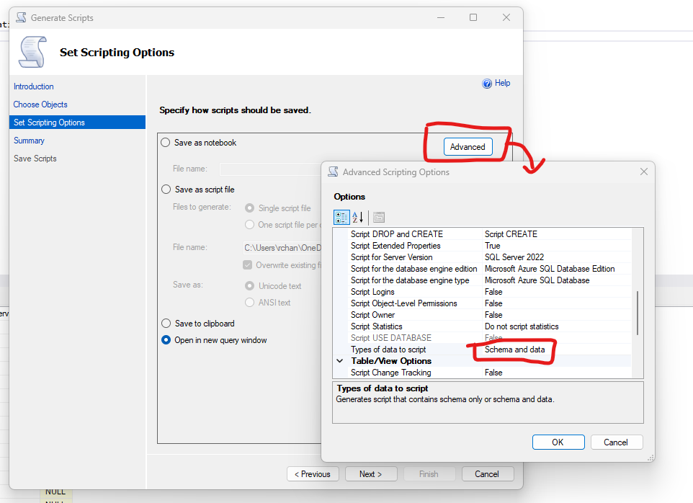
- Save your SQL script as J10_HVK_Txx.sql (where xx is your Team number)
- Take a look at the generated script and make sure you understand how it can re-create your database, even if all the tables were to be deleted. Ensure all the required functionality is there (this is what you’ll be marked on).

To hand in:
In your MS Teams folder, you will provide:

- teamNumber_A03_TableAttributeConstraint spreadsheet (two tabs, all filled in)
- original ERDPlus SQL generated file: teamNumber_A03_ERDPlusSQL
- Final SQL file of your completed and populated database: J10_HVK_Txx.sql
- This document updated with the queries and output as per Appendix A.
- Finalized team plan showing what actually happened.

Appendix A: Queries

Provide the SQL and output for the following. Note all output must be human friendly (no DB ids)

- List of all the Dogs with full details about the dogs and their Owners’ First and Last name.
SELECT Pet.PetId, Name, Species, Sterelized, SpecialNotes, Sex, BirthDate, Pet.AccountID, Breed, Size, Climber, Barker, FirstName, LastName FROM Pet
INNER JOIN Dog on Dog.PetId = Pet.PetId
INNER JOIN Account on Account.AccountId = Pet.AccountId
WHERE Pet.Species = 'dog'
- List of all Customer information
SELECT Account.AccountID as 'Account ID', Account.FirstName as 'First Name', Account.LastName as 'Last Name', Username, Type, Address, City, PostalCode as 'Postal Code', Province, HomePhone as 'Home Phone', CellPhone as 'Cell Phone', Password, EmergencyContact.EmergencyContactID as 'Emergency Contact ID', EmergencyContact.FirstName as 'Emergency Contact First Name', EmergencyContact.LastName as 'Emergency Contact Last Name', EmergencyContact.Phone as 'Emergency Contact Phone' FROM Account
INNER JOIN Customer ON Account.AccountID = Customer.AccountID
INNER JOIN EmergencyContact ON Customer.EmergencyContactID = EmergencyContact.EmergencyContactID
WHERE Account.Type = 'Customer'
- List the vaccinations for Busker and Charlie and their expiry dates
select P.Name as "Pet Name", V.Name as "Vaccination Name", PV.ExpirationDate as "Expiration Name"
from Pet P, Vaccination V, PetVaccination PV
where P.PetId = PV.PetId
and PV.VaccinationId = V.VaccinationId
and P.Name IN ('Busker', 'Charlie')
order by P.Name

- List the reservation information showing which pets, start date, end date, services booked and required medications (if any)
SELECT R.ReservationId AS "Reservation ID", P.Name AS "Pet Name", R.StartDate AS "Start Date", R.EndDate AS "End Date",
COALESCE(S.ServiceName, NULL) as "Service Booked",
COALESCE(M.Type, NULL) AS "Applied Medication"
FROM Reservation R, PetReservation PR
LEFT JOIN Medication M ON PR.PetId = M.PetId and PR.ReservationId = M.ReservationId
LEFT JOIN PetReservationService PRS ON PR.PetId = PRS.PetId and PR.ReservationId = PRS.ReservationId
LEFT JOIN Service S ON PRS.ServiceId = S.ServiceId
LEFT JOIN Pet P ON PR.PetId = P.PetId
WHERE R.ReservationId = PR.ReservationId and PR.PetId = P.PetId
ORDER BY R.ReservationId

